臺北巿立教育大學
九十九學年度研究所碩士班入學考試試題
所 別：自然科學系碩士班(科學組物理科)
不得使用計算機或任何儀具。
科 目：普通物理
考試時間：90分鐘【08:20 − 09:50】
總 分：100分
- 注意：不必抄題，作答時請將試題題號及答案依照順序寫在答卷上；限用藍色或黑色筆作答，使用其他顏色或鉛筆作答者，所考科目以零分計算。(於本試題紙上作答者，不予計分。)

- To describe the feature near the triple point of water. (15％)

- To describe the Relativity Theory of Einstein. (15％)

- The ballistic pendulum was used to measure the speeds of bullets. The large block of wood of mass M=6.5 Kg, hanging from two long cords. A bullet of mass m=10.2g is fired into the block, coming quickly to rest. Their center of mass rising a vertical distance h=7cm before the pendulum comes momentarily to rest at the end of its arc. What is the speed of the bullet just before the collision? (20％)

- A ball of mass M1 is fastened to a cord with length L. The ball is then released and at the end of its path it strikes a block of mass M2. The block is initially at rest on a frictionless table. The collision is elastic. Find (a) the speed of the ball v and (b) the speed of the block u, both just after the collision. (20％)
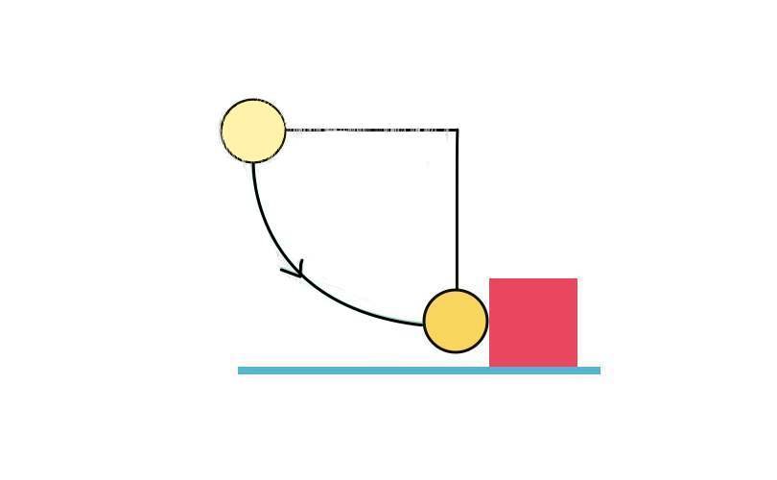Fig. 1
- A boy is initially seated on the top of a hemispherical ice mound of radius R. He begins to slide down the ice with a negligible initial speed. Approximate the ice as being frictionless. At what height does the boy lose contact with the ice?
(15％)

- Fig. 2 shows spherical shell with uniform charge density ρ. The inner and outer radius of the shell is a and b, respectively. Find the electric field at (a) r < a,
(b) a < r < b, and (c) r > b. (15％)
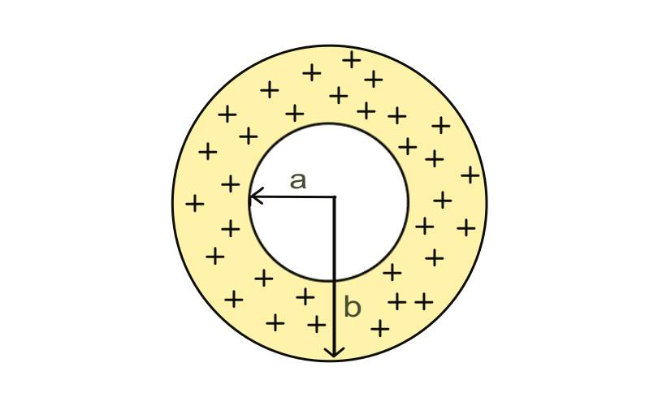
Fig. 2

